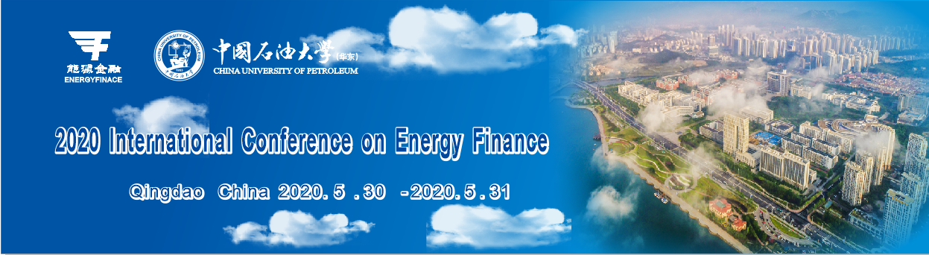

**2020 International Conference on Energy Finance (ICEF)**

*Global climate governance and energy finance: Challenges and opportunities*

**30-31 May 2020, Qingdao, China**

International conference on energy finance (ICEF) is an annual conference organized by the China Energy Finance Network (CEFN) and Chinese Society of Optimization, Overall Planning and Economical Mathematics. We are pleased to announce that China University of Petroleum will host the 2020 two-day conference in Qingdao, China.

The ICEF conferences aim to provide a platform for international scholars to share their frontier research in the subject of Energy Finance. Following the success of the series conference in Beijing (2018) and Kunming (2019), we invite submissions of high quality, original researches to the 2020 ICEF. Papers to be considered include but not limit to the following topics:

|  |  |
| --- | --- |
| * Climate and carbon finance | * Climate change economics |
| * Energy market systemic risk modelling | * Green technology innovation |
| * Green finance and investment | * Deep decarbonization |
| * Energy corporate finance | * Sustainable consumption |
| * Data-driven modelling in energy and environment | |



**Submission process and publication opportunities**

Extended abstract (please use the templates available from the website) should be submitted directly on the conference website at <http://www.cnefn.com> no later than 15 February 2020.

Selected high quality papers will be considered for publication in the special issues of one of our conjunction journals:

***Energy Economics (SSCI, JCR Q1, ABS 3, ABDC A*)***

https://www.journals.elsevier.com/energy-economics

***International Review of Financial Analysis (SSCI, JCR Q2, ABS 3, ABDC A)***

<https://www.journals.elsevier.com/international-review-of-financial-analysis/>

***International Review of Economics and Finance (SSCI, JCR Q2, ABS 2, ABDC A)***

https://www.journals.elsevier.com/international-review-of-economics-and-finance/

***Finance Research Letters (SSCI, JCR Q2, ABS 2, ABDC A)***

https://www.journals.elsevier.com/finance-research-letters/



**Guest editors:**

**Zhongxiang Zhang,** *Professor, Tianjin University*

**Qiang Ji,** *Associate Professor, Institutes of Science and Development, Chinese Academy of Sciences, China*

**Dayong Zhang,** *Professor, Southwestern University of Finance and Economics, China*

**Ronald D. Ripple,** *Professor,* *KAPSARC, Saudi Arabia*

Papers submitted must not be under review, accepted for publication, or published in any other journal. All papers will be refereed and decisions on accepted papers should be conveyed to authors by the guest editors. Acceptance to the Special Issue Conference does not guarantee acceptance into the Special Issue.

Editor Forum

**A special editor forum will be organized to share Journal scope, interesting research, publication experience et al.**

**Bin Chen**, Journal of Cleaner Production (Executive editor)

**Boqiang Lin,** Energy Economics (Co-editor)

**Brian Lucey,** International Review of Financial Analysis (Editor)

**Peng Zhou,** Energy Policy (Editor)

**Samuel A. Vigne,** Finance Research Letters (Chief-Editors)

**R.H. von Haefen,** Journal of Environmental Economics and Management (Chief-Editors)

Others…

Keynote Speakers

|  |  |
| --- | --- |
|  | **Shouyang Wang**  Chinese Academy of Sciences |
|  | **R.H. von Haefen**  North Carolina State University |



|  |
| --- |
| **Organizer** |
| * China Energy Finance Network |
| * China University of Petroleum |
| * Chinese Society of Optimization, Overall Planning and Economical Mathematics |
| **Co-organizers** |
| * Institutes of Science and Development, Chinese Academy of Sciences |
| * Southwestern University of Finance and Economics |
| * International Society for Energy Transition Studies |
| * Branch of Information and Management, Youth Innovation Promotion Association of Chinese Academy of Sciences |

**Conference Chair**

**Jianping Li**, *Chinese Academy of Sciences, China*

**Dayong Zhang**, *Southwestern University of Finance and Economics, China*

**Peng Zhou**, *China University of Petroleum, China*

**Scientific committee Chair**

**Qiang Ji**, *Chinese Academy of Sciences, China*

**Organizing committee Chair**

**Jun Wang,** *China University of Petroleum, China*

**Bingquan Liu**, *China University of Petroleum, China*

**Scientific committee**

**Ali M. Kutan**, Southern Illinois University Edwardsville, USA

**Aviral Kumar**, Tiwari, Montpellier Business School, France

**Boqiang Lin**, Xiamen University, China

**Brain Lucey**, Trinity College Dublin, Ireland

**Dayong Zhang**, Southwestern University of Finance and Economics, China

**Duc Khuong Nguyen**, IPAG Business School, France

**Elie Bouri**, Holy Spirit University of Kaslik, Lebanon

**Jian Yang**, University of Colorado, USA

**Jianping Li**, Chinese Academy of Sciences, China

**Peng Zhou**, Nanjing University of Aeronautics and Astronautics, China

**Qiang Ji**, Chinese Academy of Sciences, China

**Rangan Gupta**, University of Pretoria, South Africa

**Ronald D. Ripple**, KAPSARC, Saudi Arabia

**Samuel A. Vigne**, Trinity College Dublin, Ireland

**Shouyang Wang**, Chinese Academy of Sciences, China

**Ugur Soytas**, Middle East Technical University, Turkey

**Xingguo Luo**, Zhejiang University, China

**Xunpeng Shi,** University of Technology Sydney, Australia

**Ying Fan**, Beihang University, China

**Yudong Wang**, Nanjing University of Science and Technology, China

**Zhongxiang Zhang**, Tianjin University, China

**Organizing committee**

**Hui Wang**, China University of Petroleum (East China), China

**Mingming Zhang**, China University of Petroleum (East China), China

**Wen Wen**, China University of Petroleum (East China), China

**Yan Zhang**, China University of Petroleum (East China), China

**Rui Hou**, China University of Petroleum (East China), China

**Ying Li**, China University of Petroleum (East China), China

**Feng Fu**, China University of Petroleum (East China), China

**Guixin An**, China University of Petroleum (East China), China

**Jianmin Qi**, China University of Petroleum (East China), China

**Ling Jian**, China University of Petroleum (East China), China

**Yongbo Li**, China University of Petroleum (East China), China

**Xiaofeng Xu,** China University of Petroleum (East China), China

**Yong Wang**, China University of Petroleum (East China), China

**Zhonggang Xie**, China University of Petroleum (East China), China

**Peng Zhou**, China University of Petroleum (East China), China

**Jun Wang**, China University of Petroleum (East China), China

**Yanfang Sun**, China University of Petroleum (East China), China

**Haidong Zheng**, China University of Petroleum (East China), China

**Bingquan Liu**, China University of Petroleum (East China), China

**Xiaolei Sun**, *Chinese Academy of Sciences, China*

**Yinpeng Liu**, *Chinese Academy of Sciences, China*

**Yan Xia***, Chinese Academy of Sciences, China*



**Important dates:**

* Abstract submission deadline: 15 February 2020
* Notification of Acceptance: 28 February 2020
* Full paper submission deadline (SI recommendation requirements): 15 April 2020
* Registration deadline: 30 April 2020
* Conference: 29-31 May 2020 (Registration date 29 May)
* Submissions to the special issues: 15 July 2020

**Registration and fee payment:**

The registration fee includes conference materials, coffee breaks, lunch buffets, and gala dinner

|  |  |  |  |
| --- | --- | --- | --- |
| **International participant** | | **Chinese participant** | |
| Regular participant | $400 | Regular participant | 2600 RMB |
| Student | $260 | Student | 1600 RMB |
| Accompany person | $260 | Accompany person | 1600 RMB |

Please send us an email for any enquiry: <http://www.cnefn.com/index.html?init=7.1>

For more information, please refer to the conference website: <http://www.cnefn.com>