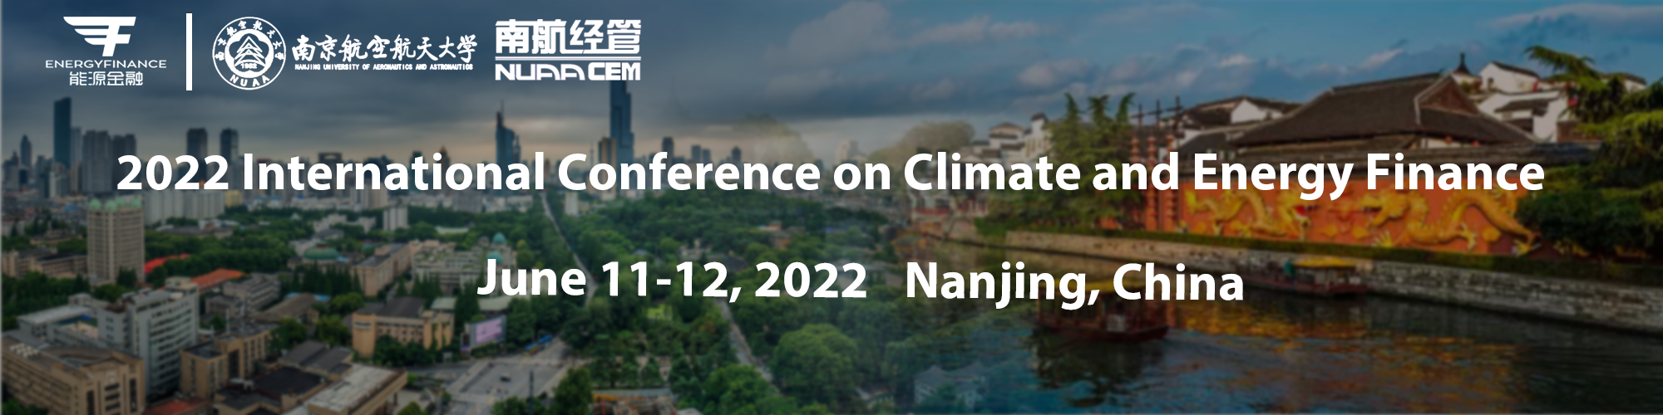

Call for Papers

**2022 International Conference on Climate and Energy Finance (ICEF 2022)**

*Energy and Climate Risks in the Energy Transition*

**June 11-12, 2022, Nanjing, China**

The International Conference on Climate and Energy Finance (ICEF) is an annual conference organized by the China Energy Finance Network (CEFN) and Chinese Society of Optimization, Overall Planning and Economical Mathematics. We are pleased to announce that the ICEF 2022 will be held by Nanjing University of Aeronautics & Astronautics in Jinling Resort Nanjing between June 11-12, 2022.

The ICEF conferences seek to provide a platform for international scholars to share their frontier research on the subject of Climate and Energy Finance. Following the success of the past events in Beijing (2018), Kunming (2019), Qingdao (2020) and Xiamen (2021), we sincerely invite submissions of high quality, original researches to the ICEF 2022.

Papers to be considered include but are not limited to the following topics:

|  |  |
| --- | --- |
| * Big-data analytics in energy finance | * Climate finance |
| * Climate risk and financial markets | * Carbon finance |
| * Energy market: modelling and pricing | * Energy finance and investment |
| * Energy market integration | * Environmental governance |
| * Financing de-carbonization in cities | * Green innovation |
| * Household behavior | * Pathways to carbon neutral |



**Submission process and publication opportunities**

An extended abstract should be submitted to the online portal at the conference website [http://www.cnefn.com/](http://www.cnefn.com/index.html?init=7.1).

Papers submitted to the conference have the opportunity to publish in one of the special issues. Qualified papers will be invited to submit to the suitable journal based on recommendations by the guest editors and editors. Please note that the recommendation does not guarantee final publication, all regular requirements by journals have to be satisfied.

**List of special issue journals:**

* ***International Review of Financial Analysis (SSCI, JCR 1, ABS 3, ABDC A)***
* ***Finance Research Letters (SSCI, JCR 1, ABS 2, ABDC A)***
* ***Resources Policy (SSCI, JCR 1, ABS 2, ABDC B)***
* ***International Review of Economics and Finance (SSCI, JCR 2, ABS 2, ABDC A)***
* ***Frontiers in Environmental Science (SSCI, JCR 2)***
* Forthcoming…



* Submissions to the special issues: 30 July 2022

**Important dates:**

* Abstract submission deadline: 15 April 2022
* Notification of Acceptance: 30 April 2022
* Full paper submission deadline (for special issues): 20 May 2022
* Registration deadline: 25 May 2022
* Conference: 11-12 June 2022

**Conference location: Nanjing**

**Registration fee:**

|  |  |  |  |
| --- | --- | --- | --- |
| **International participant**  **(Online session)** | | **Chinese participant** | |
| Regular participant | $400 | Regular participant | 2600 RMB |
| Student | $260 | Student | 1600 RMB |

**Note: All the international participants can attend online sessions and also enjoy the 50% fee discount.**

Please send us an email for any enquiries: energyfinance@126.com

For more information, please refer to the conference website: <http://www.cnefn.com/.>